
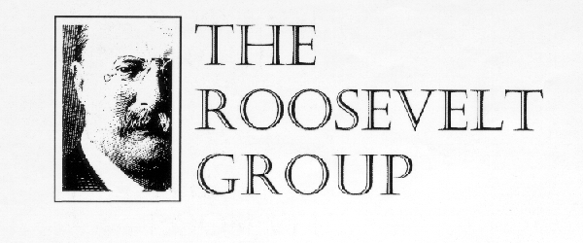

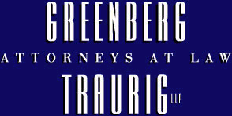

CFO Summit

The University Club

Washington, DC

October 7-8, 2004

The symposium will help provide chief financial officers and other corporate financial executives with a comprehensive discussion of some of the critical issues currently facing the corporate financial community. CFOs will have an opportunity to discuss questions and concerns of interest to them with nationally recognized thought leaders and peers during addresses, presentations, refreshment breaks, lunches and an evening reception.

Preliminary Agenda

Thursday, October 7, 2004
8:30 am Continental Breakfast
9:00 -9:30 am Opening Keynote Address

“Returning Confidence to the U.S. Economy”

N. Gregory Mankiw, Chairman, President’s Council of Economic Advisors

9:30-10:15 am Results of the Best Practices Survey in Financial Performance
Richard Roth, Chief Research Officer, Hackett Group

10:15-10:30 am Refreshment Break
10:30-12:00 pm CFO Peer Roundtable on Critical Financial Management Issues
John Morse, CFO Ronald Spoehel, CFO W. Ed Walter, CFO

The Washington Post MAN Host Marriott
12:00-1:45 pm Luncheon and Keynote Address
“The SEC Today”
William Donaldson, Securities and Exchange Commission
1:45-2:45pm Performing a Fiduciary Audit
Jeffrey Mamorsky, Partner
Greenberg-Trauig

2:45-3:00 pm Refreshment Break
3:00-4:30 pm SEC Reporting and Disclosure Initiatives
- Sarbanes Oxley regulatory initiatives
- New Form 8-K requirements
- Recently adopted regulations
- Proposed rule changes
Scott Harrison, KPMG
4:30-5:30 pm Sarbannes-Oxley: A Postscript
Sen. Paul Sarbanes (D)
Rep. Michael Oxley (R)

5:30 pm Reception

Friday, October 8, 200400 am Continental Breakfast
8:30-9:30 am New Opportunities in the Capital Markets and Risk Management

Josh Mazer and Richard Barron, Sun Trust

9:30-9:45 am Refreshment Break
9:45-11:00 am FASB Update
An analysis of recent pronouncements issued by the FASB including the expected new statement amending FASB Statement 133, the new exposure draft on disclosures about fair value, the expected exposure draft on purchase method procedures, the new statement on consolidation of special purpose entities, the new statement on guarantor's accounting and disclosure requirements for guarantees, financial performance reporting by business enterprises, the project to issue a comprehensive statement on revenue recognition; Emerging Issues Task Force developments.
Edward W. Trott, Board Member
Financial Accounting Standards Board

11:00-12:00 am CFOs and the Audit Committee: Independence and Performance
Steve Anderson, Chairman
Marsh FINPRO
John B. Veihmeyer

KPMG

Stan Dore, Senior Vice President
Riggs National Corporation

Caroline Brancato, the Conference Board

Conclusion
Organized and Produced by The Roosevelt Group

